**ASSIGNMENT**

**04-09-2025**

**CONDITIONAL FORMATTING:**

**1.**

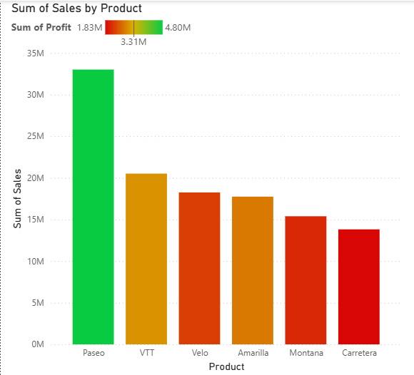

STEPS:

* When we have to represent two measures in one chart we use this conditional formatting.
* In this case I wanted to represent both product wise profit and product wise sales in the same chart so conditional formatting helps.
* In Visualization pane, select the column chart and populate it with product in x-axis and sales in y-axis.
* Go inside format visual pane and select columns inside it we find color option beside is the conditional formatting option with “fx” on the button.
* Click on conditional formatting and a dialog box appears as below.

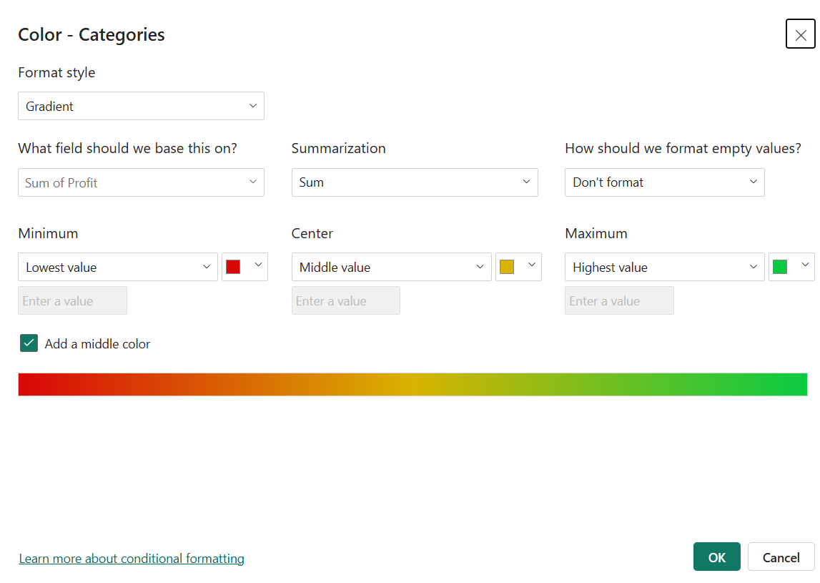

* Select the format style to Gradient, select the field to base on as profit and don’t format empty values, select different color gradients for minimum, maximum and middle values, click on OK.
* We can see the interpretation in the chart plotted in order of sales and colored in order of profit.

2.

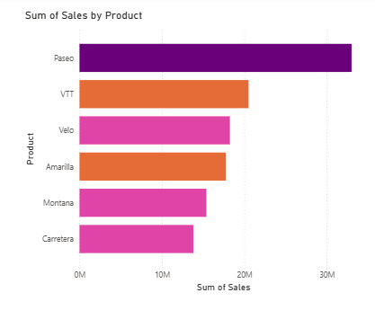

STEPS:

* In this case I wanted to represent both product wise profit and product wise sales in the same chart so conditional formatting helps.
* In Visualization pane, select the column chart and populate it with product in x-axis and sales in y-axis.
* Go inside format visual pane and select columns inside it we find color option beside is the conditional formatting option with “fx” on the button.
* Click on conditional formatting and a dialog box appears as below.

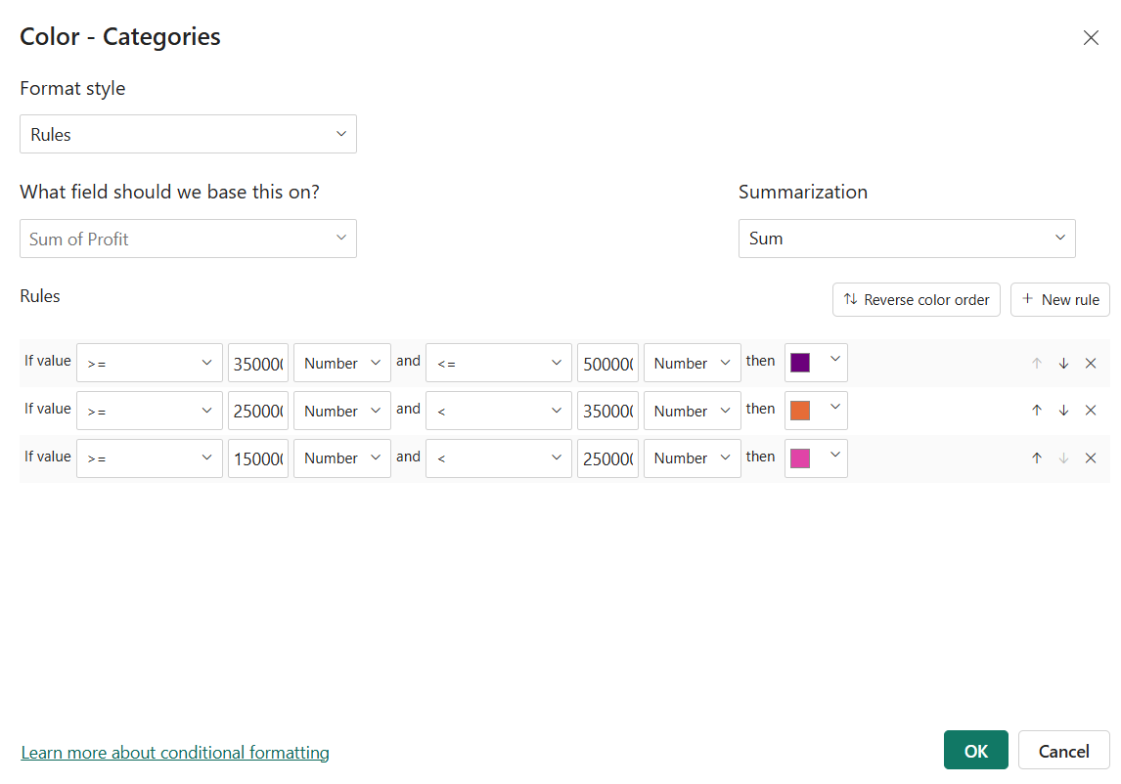

* In the Format style select Rules and field to base on as profit, then you can give the rules and for every rule give different color. Press OK.
* We can see the interpretation of conditional formatting in the chart.
* The products are ordered as per sales and colored based on profit range.

3.**FILTERS**

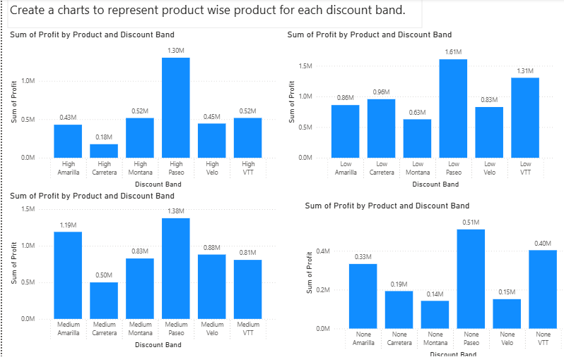

STEPS:

* In the question we are asked to represent the product wise profit for each of the discount band separately.
* To represent more than two values in a chart we use filter, Filters are totally used by developers and can’t be used by users.
* To do so we are using Filters, first start by creating a chart with product in x-axis and profit in y-axis.
* Drag and drop the discount band in the x-axis now we can see the product wise profit divided by discount bands.
* Now go to filters pane and navigate to discount band section and select one discount band.
* Replicate the chart for three more times and select different band for each chart.
* Turn on the data labels and there we go with the product wise profit for each discount bands.

**4.SMALL MULTIPLES**

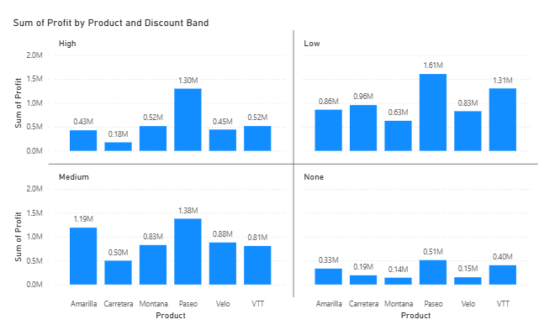

STEPS:

* For the same above question instead of creating four different charts manually we can create all at once using small multiples.
* Start selecting the visual from build visual pane and drag and drop products to x-axis, profit to y-axis and profit to the small multiples’ fields.
* Automatically the chart like above gets created as easy, time saving and effective.